Domaći zadatak 3

Ristovski Nikola 19347

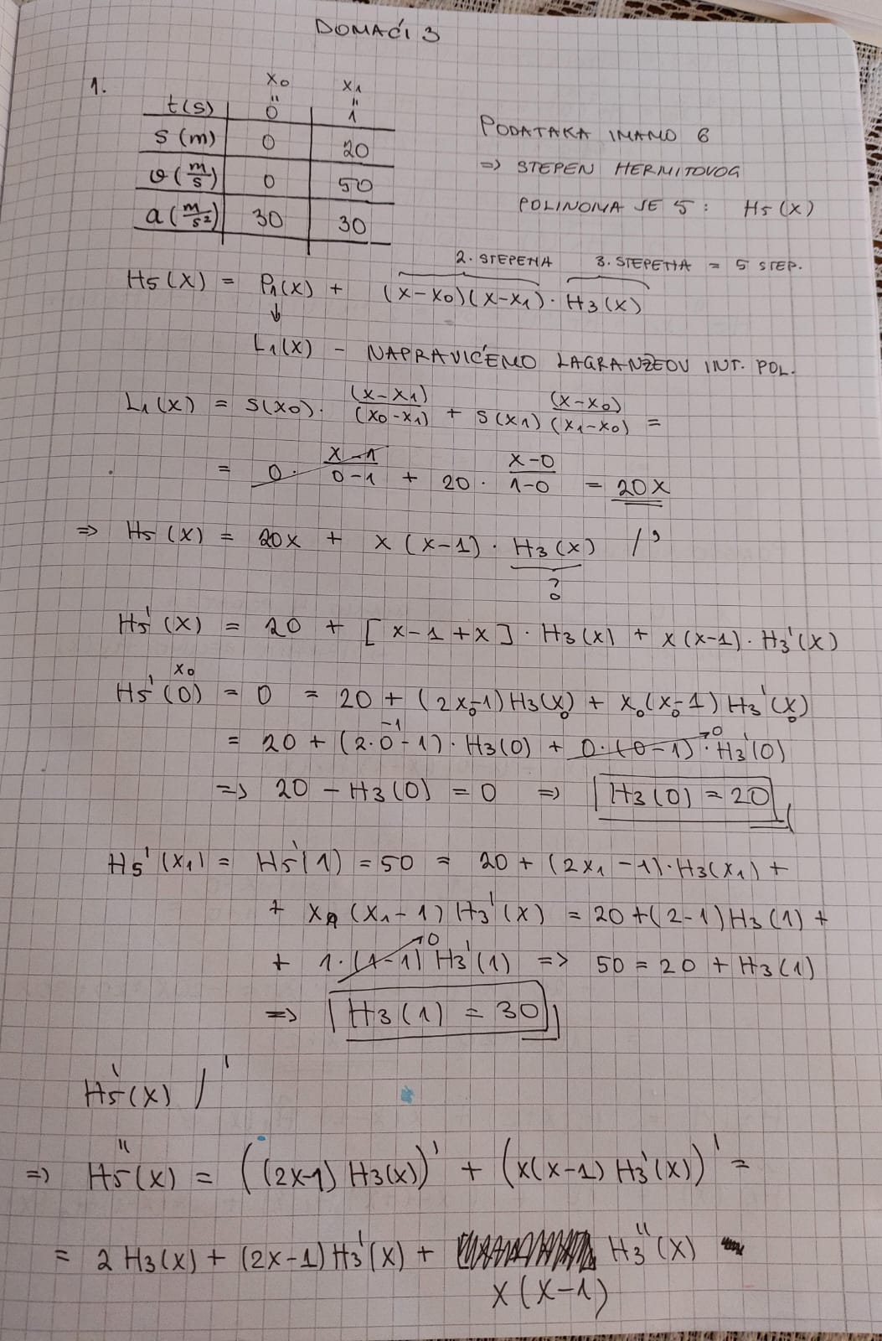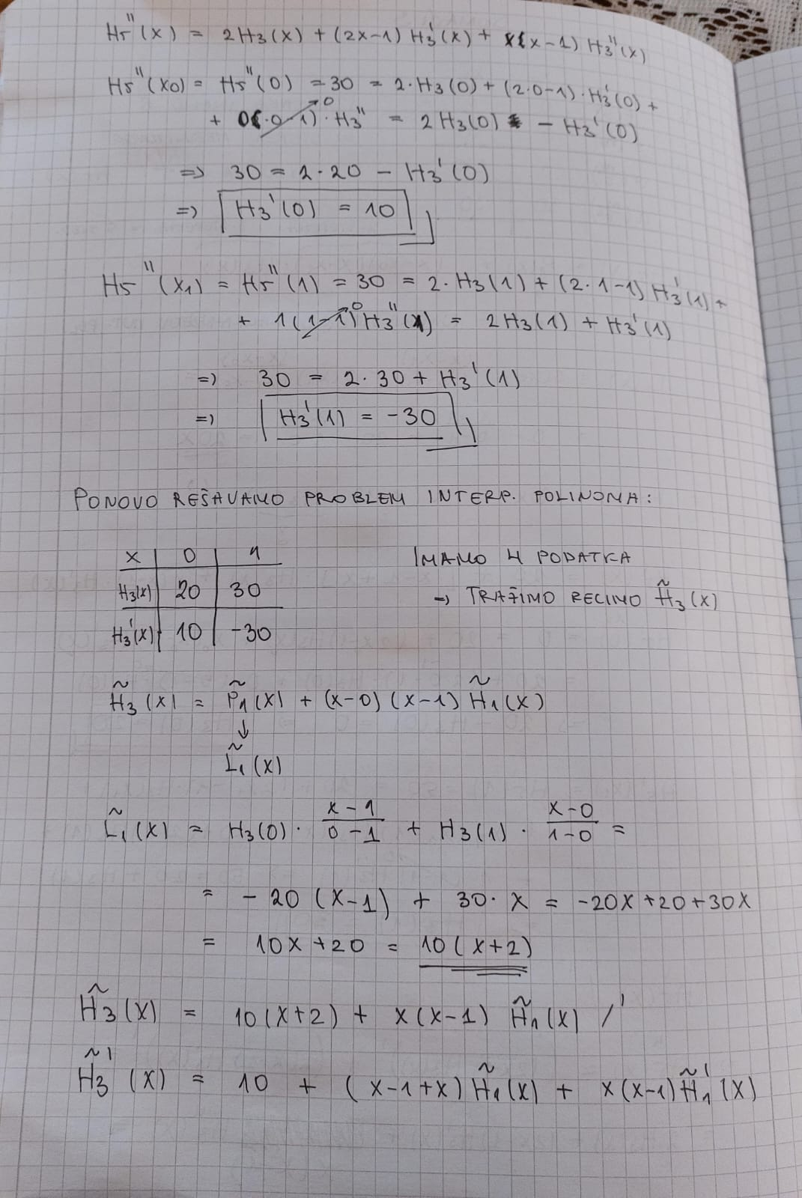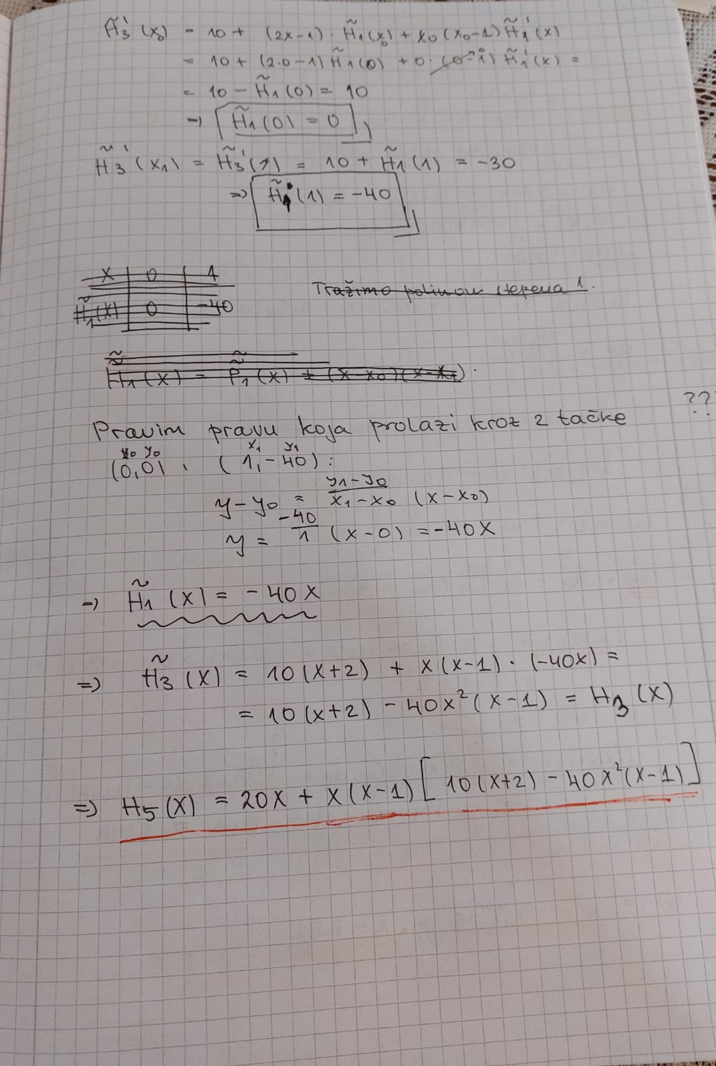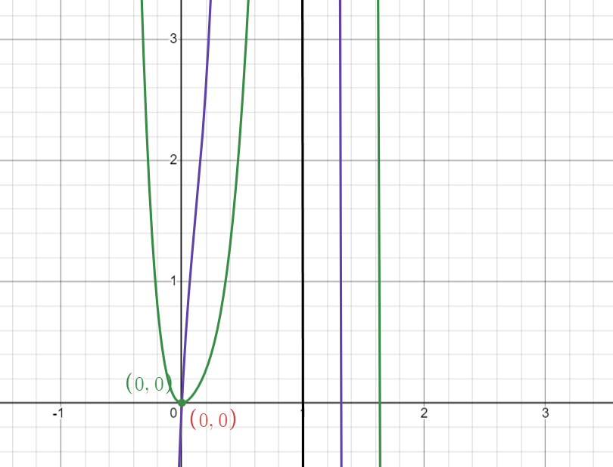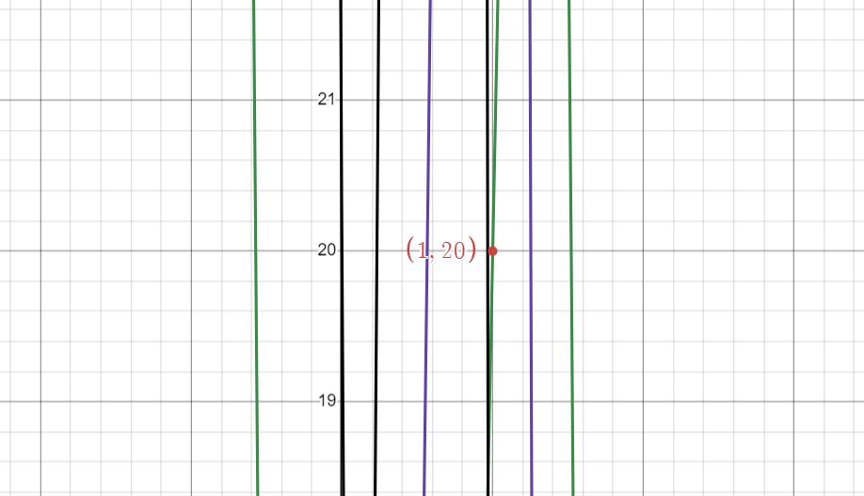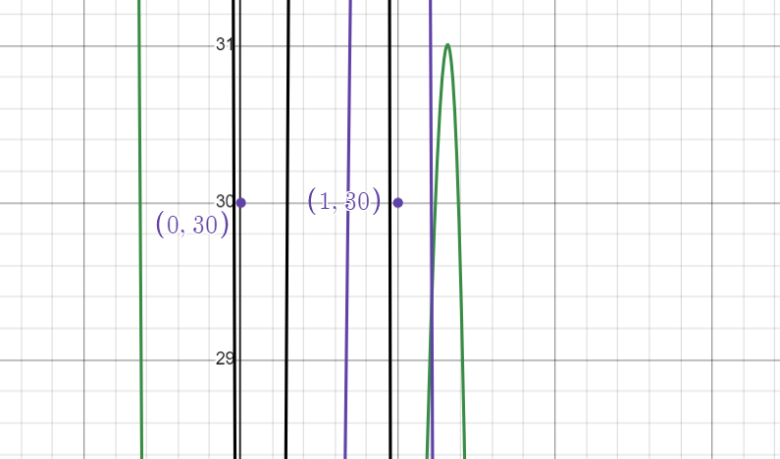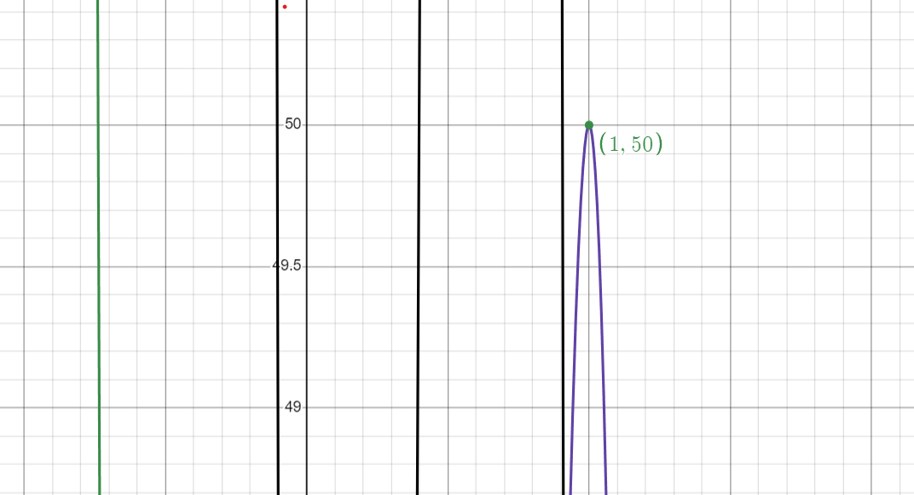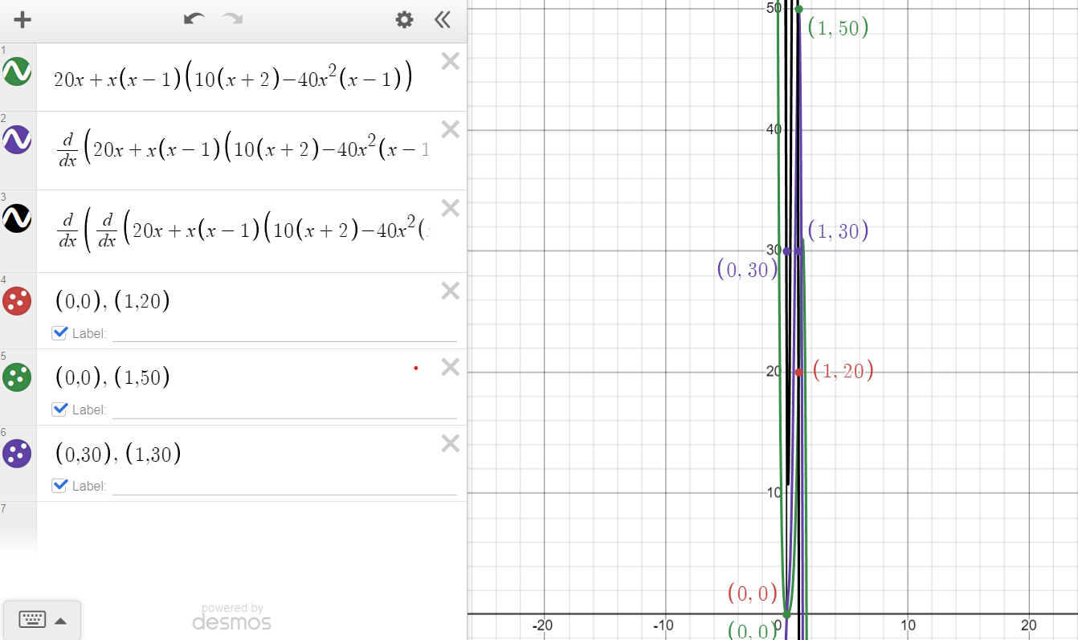

* **Zeleno** – aproksimacija, hermitov polinom
* **Ljubičasto** – njegov prvi izvod
* **Crno** – njegov drugi izvod
* Prisutne su i **tačke** koje odgovaraju vrenostima parova vremena i puta, brzine odnosno ubrzanja

* **Crveno** – funkcija
* **Plavo** – aproksimacija

* Van segmenta, javlja se **veliko** odstupanje.

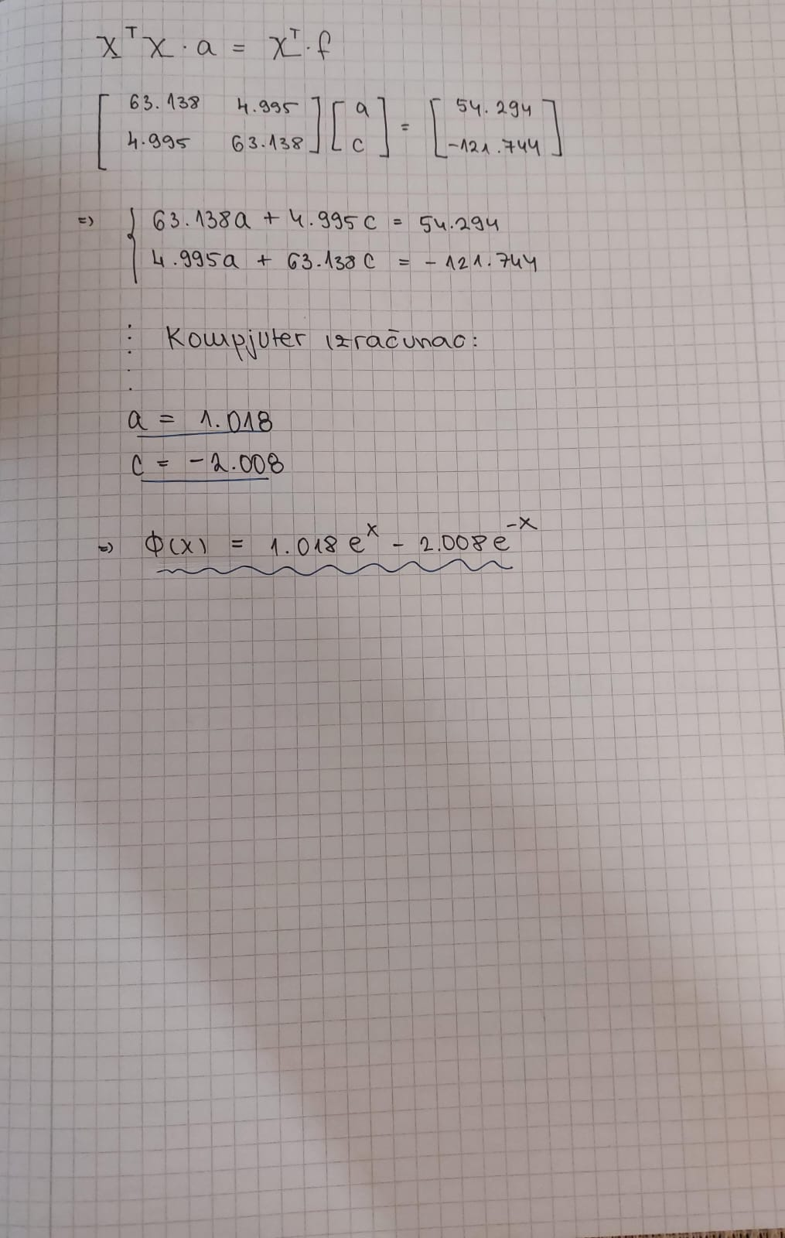

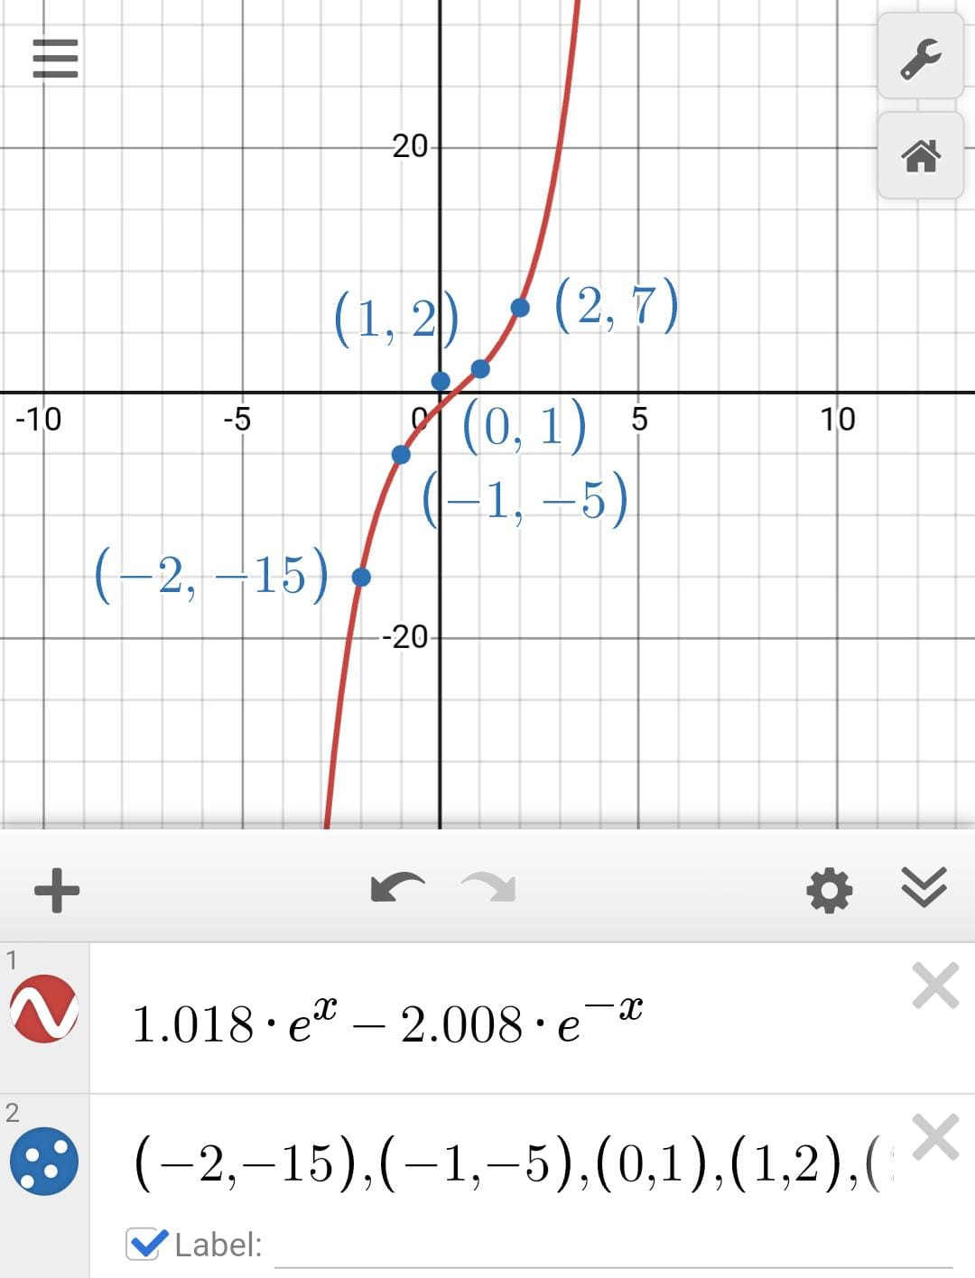

* **Crveno** – aproksimacija
* **Plavo** – date vrednosti x i funkcije f(x)